**1. LIST TOTAL LOAN**

select sum(amount) as Total_Loan from borrow;

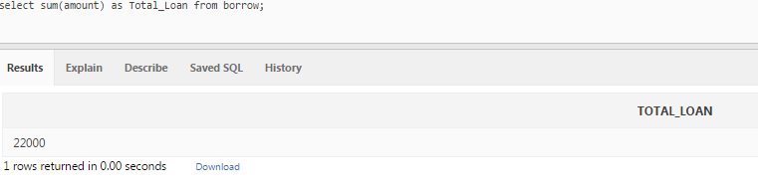

**2. LIST TOTAL DEPOSIT**

select sum(amount) as Total_Deposit from deposit;

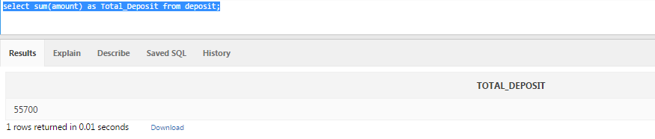

**3. LIST TOTAL LOAN TAKEN FROM ANDHERI BRANCH**

select bname,sum(amount) as Total_Branch_Deposit from deposit where bname = 'ANDHERI' group by bname;

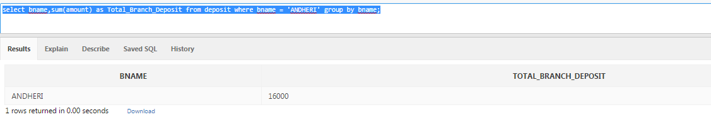

**4. LIST TOTAL DEPOSIT OF CUSTOMER HAVING ACCOUNT DATE LATER THAN 1-JAN-96**

select sum(amount) as Total_Deposit_by_date from deposit where adate > '01-JAN-1996';

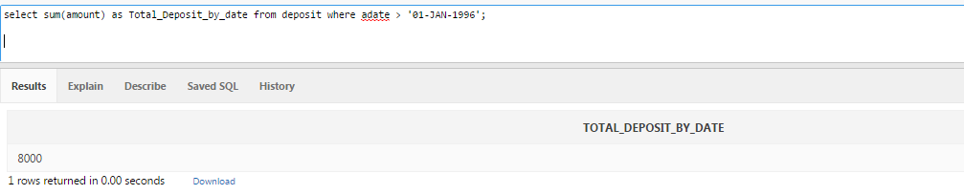

**5. LIST TOTAL DEPOSIT OF CUSTOMERS LIVING IN NAGPUR**

select D.cname,sum(D.amount) as tot_deposit from (select bname from branch where city = 'NAGPUR') A,deposit D

where D.bname=A.bname

group by D.cname;

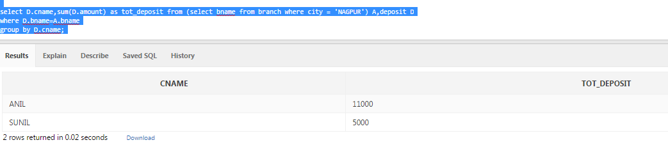

**6. LIST MAXIMUM DEPOSIT OF CUSTOMERS LIVING IN MUMBAI**

**7. LIST TOTAL DEPOSIT OF CUSTOMERS HAVING BRANCH CITY AS DELHI**

select cname,sum(amount) as total_deposit from deposit where bname in (select bname from branch where city = 'DELHI') group by cname;

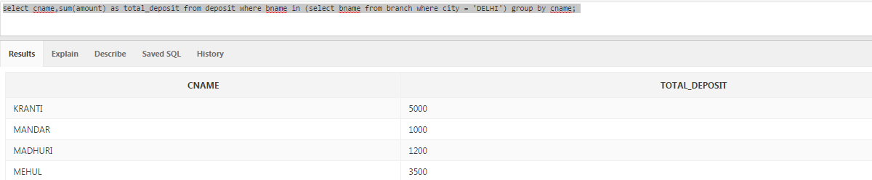

**8. LIST TOTAL DEPOSIT OF CUSTOMERS LIVING IN THE CITY WHERE SUNIL IS LIVING**

select cname,sum(amount) as tot_deposit from deposit where cname in (select cname from cust where city in (select city from cust where cname = 'SUNIL')) group by cname;

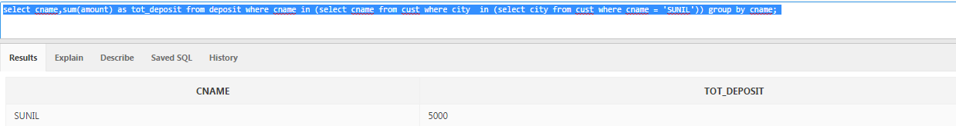

**9. COUNT TOTAL NUMBER OF BRANCH CITIES**

select city,count(bname) from branch group by city;

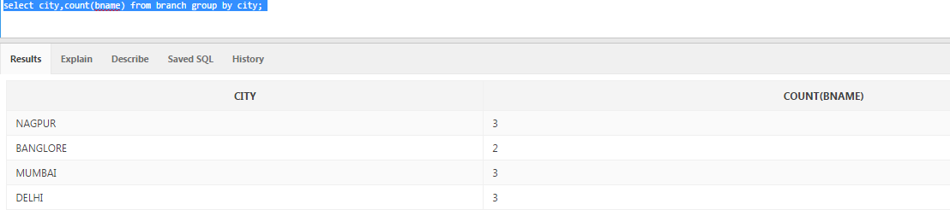

**10. COUNT TOTAL NUMBER OF CUSTOMER CITITES**

select city,count(city) from cust group by city;

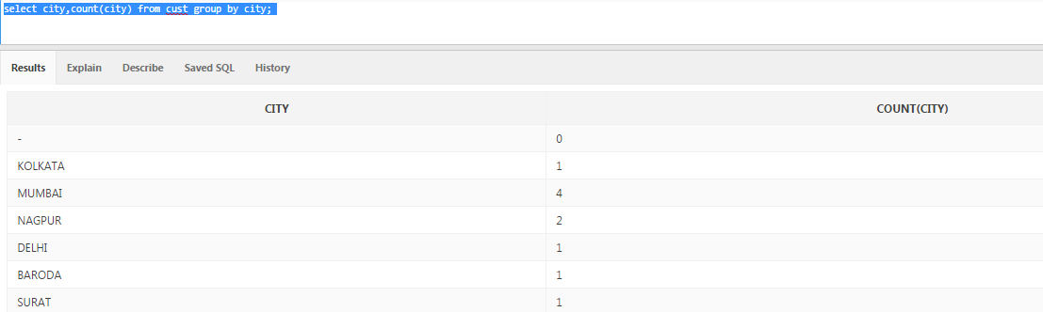

**11. LIST BRANCH NAME AND BRANCH WISE TOTAL DEPOSIT**

select bname,sum(amount) as tot_deposit from deposit group by bname;

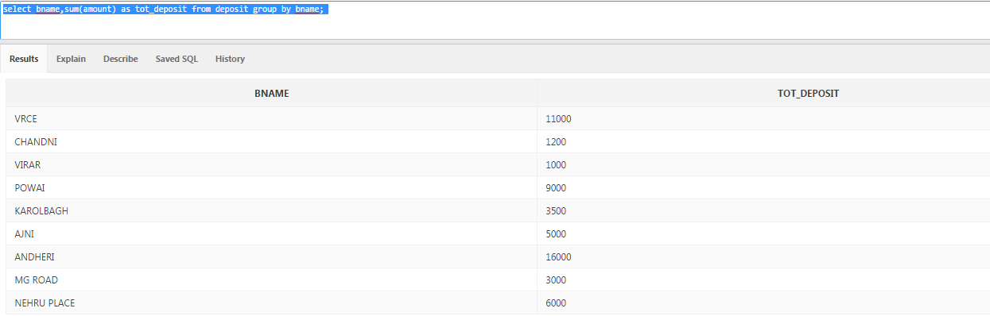

**12. LIST CITY NAME AND CITY WISE DEPOSIT**

select b.city,sum(d.amount) tot_dep from deposit d,branch b

where d.bname=b.bname

group by b.city;

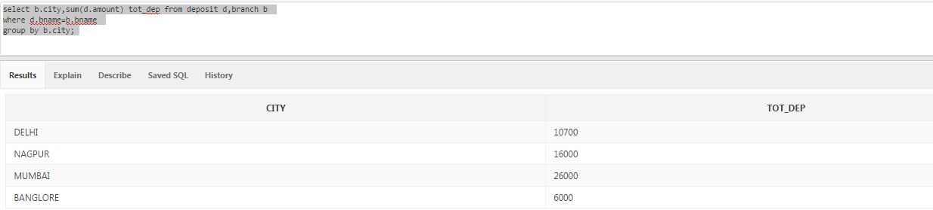

**13. LIST THE CITY WISE NAME AND BRANCH WISE DEPOSIT**

select b.city,d.bname,sum(d.amount) tot_dep from deposit d,branch b

where d.bname=b.bname

group by b.city,d.bname

order by 1;

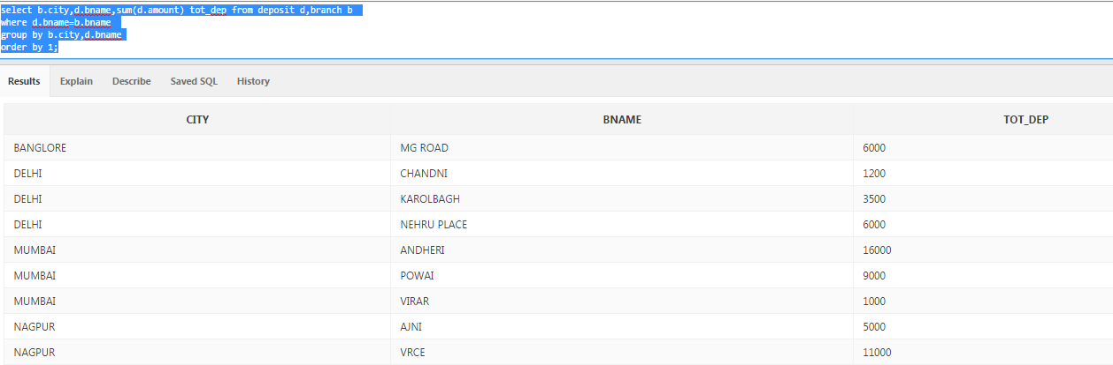

**14. LIST THE BRANCH WISE DEPOSIT OF CUSTOMER AFTER ACCOUNT DATE 1-JAN-96**

select bname,sum(amount) from deposit where adate > '01-JAN-0096' group by bname;

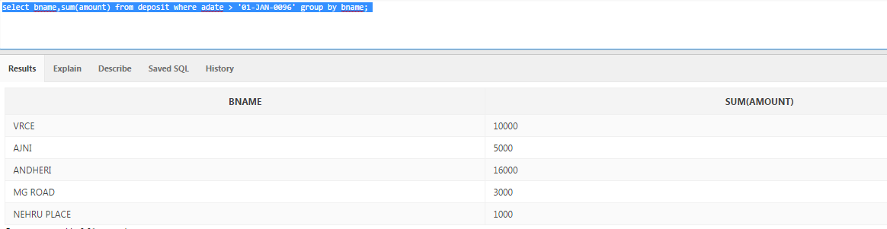

**15. LIST BRANCH WISE LOAN OF CUSTOMER LIVING IN NAGPUR**

select bname,sum(amount) as borrow_amt from borrow where cname in (select cname from cust where city = 'NAGPUR') group by bname;

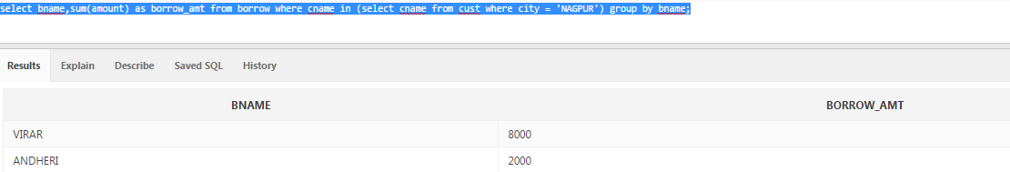

**16. COUNT TOTAL NUMBER OF CUSTOMER**

select count(cname) from (

select distinct cname from deposit

union

select distinct cname from borrow);

**17. COUNT TOTAL NUMBER OF DEPOSITORS BRANCH WISE**

select bname,count(cname) branch_cnt from deposit group by bname;

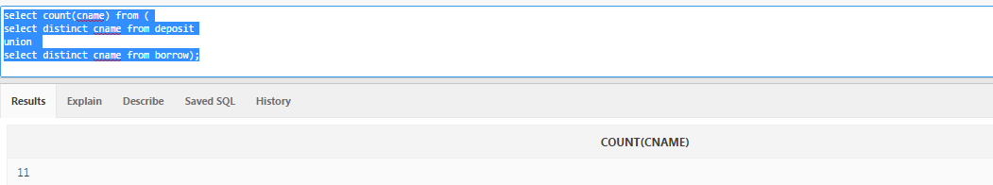

**18. LIST MAXIMUM LOAN FROM THE VRCE BRANCH**

select max(sum_borr_amt) as max_borr from

(select cname,sum(amount) as sum_borr_amt from borrow where bname = 'VRCE' group by cname);

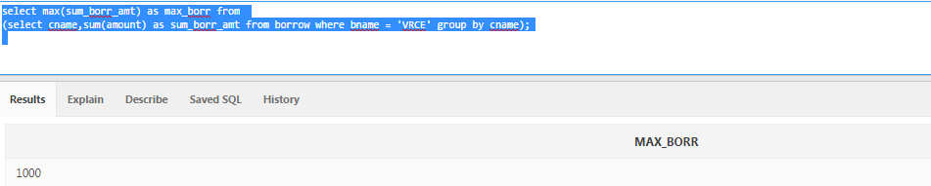

**19. LIST LIVING CITY WISE LOAN OF BORROWERS**

select A.living_city,sum(B.amount) as borr_amt from (

select bname,city as living_city from branch where city in (select distinct city from cust where cname in (select cname from borrow))) A,borrow B

where B.bname=A.bname

group by A.living_city;

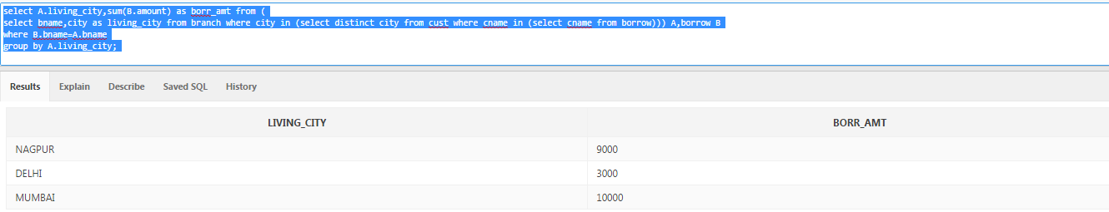

**20. LIST THE NUMBER OF CUSTOMERS WHO ARE DEPOSITORS AS WELL AS BORROWERS**

select count(D.cname) as borrower_depositor_cnt from deposit D,borrow B

where D.cname=B.cname;

